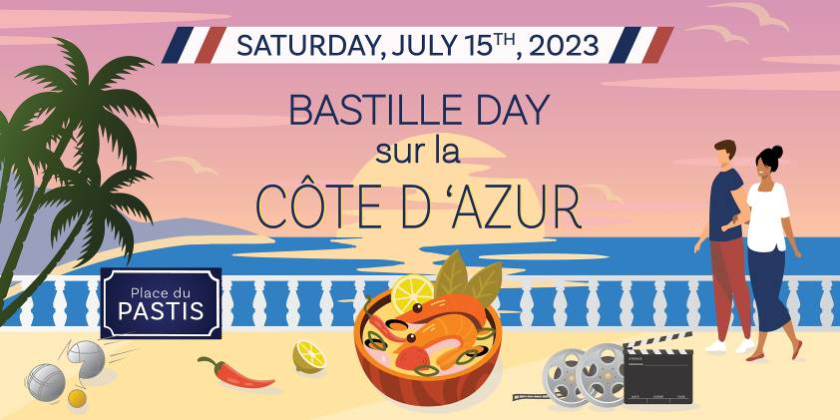
Comité Tricolore Bastille Day 2023
Auction Donation Description Form

Thank you for your generous contribution to our auction. Our auction raises much needed funds to support programs for the underprivileged in our community and your support is greatly appreciated. Please type on and complete the form below.

Company Name: __________________________________________________________

Mailing Address: __________________________________________________________
__________________________________________________________
__________________________________________________________

Contact: __________________________________________

Phone: ___________________________________________
Email: ___________________________________________

Estimated Value: _______________________________ (Tax Deductible)

Service / Item Description:

Provide instructions to redeem:

Certificate/Letter provided: Y / N If yes, attach and return with this form.

Expiration: __________________________________________________ (Suggested 7/16/2025)
(Date must be at least 1 year from July 16, 2023)

Return by email to event@comite-tricolore.org or send to:
Attention: Raphaèle Holley
La Maison Française, Embassy of France
4101 Reservoir Road NW
Washington DC 20007

